Enrollment Center
Eligibility Check - In order to ensure that customers are eligible for PrePay Enrollment, a new ruleset for eligibility rules will be built in BRF+ (similar to the existing DPP and DLA Eligibility checks designed in BRF+). This new set of eligibility rules will be called when the CSR initiates the PrePayment screen.
Enrollment Center screen has four main component
- Participating program
- Available program
- Eligibility Messages
- Program History
Before displaying the enrollment center, Eligibility check is performed on the programs to check whether the programs are eligible or not.
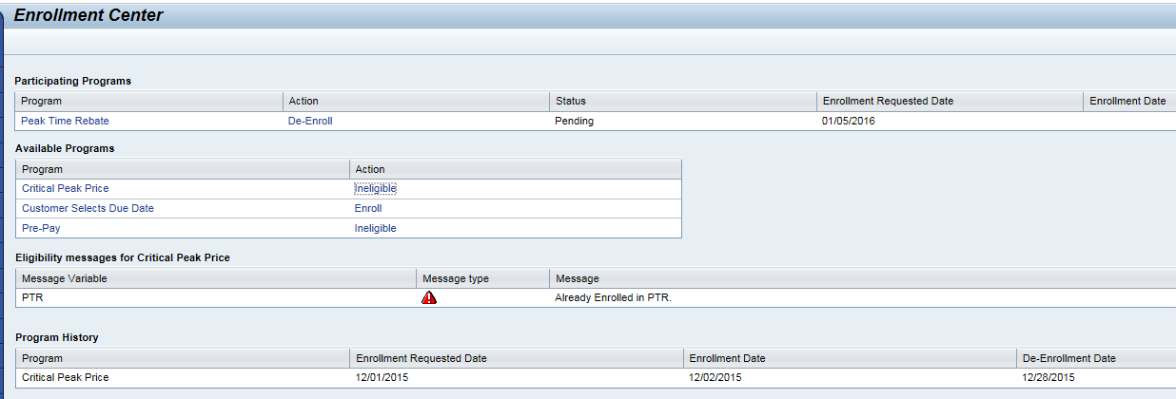
By implementing this solution the CE CSRs will require minimal effort in enrolling/de-enrolling a customer into PrePay program. They will also achieve greater visability into the customer’s program participation.

Technical Design:
Function Modules:
ENHANCEMENT DESIGN SPECIFICATIONS:
Enhancement Requirements
Number | Description of Requirement
1 | Creation of new Function Module to check the basic eligibility checks for the respective programs.
2 | Creation of System Message in CRM prompting Customer Program Enrollment and Navigation to Enrollment Center.
3 | Creation of Enrollment Center component to show the CSR with the enrolled/eligible programs along with the eligibility messages and also the program history.

PrePay Enrollment Eligibility Details
In order to ensure that customers are eligible for PrePay Enrollment, a new ruleset for eligibility rules will be built in BRF+ (similar to the existing DPP and DLA Eligibility checks designed in BRF+). This new set of eligibility rules will be called when the CSR initiates the PrePayment screen.

The scenarios in which eligibility will be called are as follows:
- At the time of Move In, only if a PrePay Enrollment associated with the Business Partner sometime in the past has been identified (see PJT03030.R5.PrePay.FS.CRM_ENH_PP_001.v0.1 for details on whether or not to prompt for PrePay Enrollment).

The eligibility check will be ran in background in parallel with eligibility checks from other SE programs. The trigger for this option will be navigation to the Enrollment Center screen. Once the screen is initiated the call to ECC BRF+ will be made and the eligibility checks for all SE programs will be ran. The eligible programs will be shown for the CSR and the ineligible reasons for each program will be displayed for the CSR.

Regardless of the way the BRF+ PrePay Enrollment eligibility rules are called, BRF+ will always execute the same set of business rules to identify whether or not the account is eligible. There is no rule sequence required for PrePay. All rules need to be checked and all failures need to be sent to CRM and displayed on the enrollment screen.

If the account does not pass all of the BRF+ eligibility rules for PrePay Enrollment, the error will be returned to CRM. This error or errors will all need to be displayed to the CSR on the enrollment screen. There will be hard stop errors and warning messages. The CSR can enroll a customer on PrePay even with a warning message being displayed. However a customer will not be able to enroll if they have a hard stop error. The CSR will have the ability to see the error and how to correct it if the customer would like to enroll.

The eligibility BRF+ is designed in such a way that it can be called from CRM as well as ECC. And it can be called for multiple CA with multiple Program types at once, then it will give the results for all the supplied Contract Accounts at once.

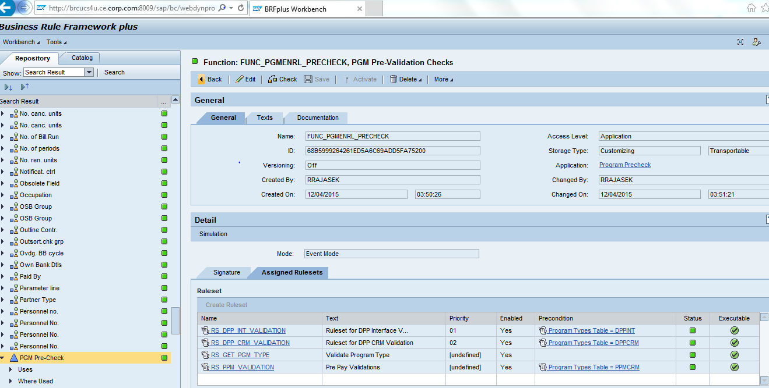

FUNC_PGMENRL_PRECHECK

Rule Set:- RS_DPP_INT_VALIDATION, Ruleset for DPP Interface V...
Rule No 12:- Rule: RU_DPP_CHECK_NOAIRDIV, Check Whether Device has ai...

